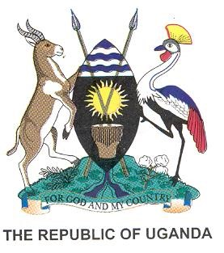

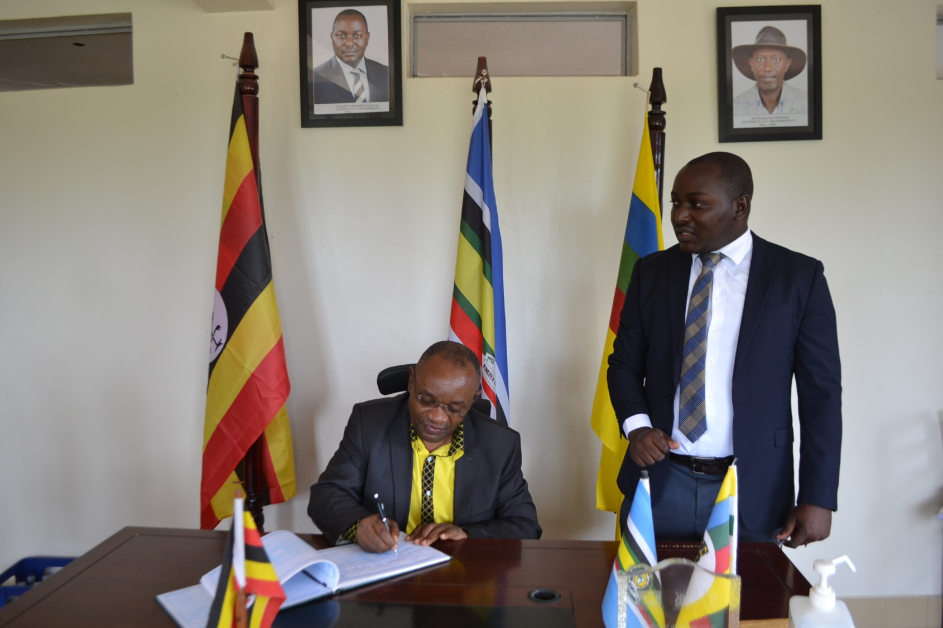
STATE OF LWENGO DISTRICT AFFAIRS ADDRESS

FINANCIAL YEAR
2022/2023

Presented by
Hon Kitatta Ibrahim Al Malik
District Chairperson
On 29th June 2023

STATE OF THE DISTRICT AFFAIRS

Mr. Speaker,
The Hon. Deputy Speaker
Resident District Commissioner,
Hon. Vice Chairperson
Members of the District Executive Committee,
Hon. District Councilors
Hon Members of Parliament,
The Chief Administrative Officer,
Members of Boards and Commissions,
Religious Leaders
Sub County Chairpersons
Development Partners
Heads of Departments and Sections
Distinguished Guests,
Ladies and Gentlemen

In fulfillment of Statutory requirements under the Local Government Act Cap 243, Sub
Section 13(5) it is with great pleasure that I stand to deliver the State of the
District Affairs Address to the District Council for the financial year ending 30th June 2023

It’s our vision as leaders of Lwengo District to have “A transformed Lwengo community from a peasant to a modern and prosperous society by 2040” This vision is in line with the Goal of the third National Development Plan 2020/21- 2024/25 (as Revised) which aims at increasing household incomes and improving the quality of life.
To achieve the above vision, the District has been and will continue to pursue a number
of development strategies including:
- Maintaining peace and good governance.
- Commercialization of agriculture
- Reduce the cost of doing business
- Harnessing tourism potential
STATE OF THE DISTRICT AFFAIRS
- Promote private sector investment
- Fight Corruption in all its forms
- Mindset change to promote focus on development
- Increasing Local Revenue Mobilization
- Fight Extreme Poverty and Hunger
- Promotion of social services.
- Ensure that, children will be able to complete a full course of primary schooling.
- Reduce Child Mortality
- Foster infrastructural development at all levels
- Enhance provision of quality education at all levels
- Ensure environmental sustainability
- Promote Gender Equality and Empowerment of women
As you all know that our District has grown leaps and bounds since July 2010 when it was curved off Masaka, Lwengo is now 12 years, 11months.
Mr. Speaker Sir, allow me to bring to your attention some of the key events that have unfolded in the District since we took office two years ago.
- Recently we Met His Excellency the President for the Republic of Uganda in Masaka
- We were blessed to have Hosted the Right Honorable Prime Minister of Uganda Robina Nabbanja in Kyazanga Sub county
- Hosted the Right Honorable Deputy Speaker of Parliament, Thomas Tayebwa
- Hosted the Hon Mpuuga Mathias Leader of Opposition in Parliament
- Hosted AlHaj Moses Kigongo the First National Vice Chairman of the NRM
- Hosted the Hon Ministers of; Defence, Presidency, Lands, Local Government, State for Education (Higher Education), State for Health (General Duties) State for Finance (Micro Finance), State for Local Government, and others

STATE OF THE DISTRICT AFFAIRS
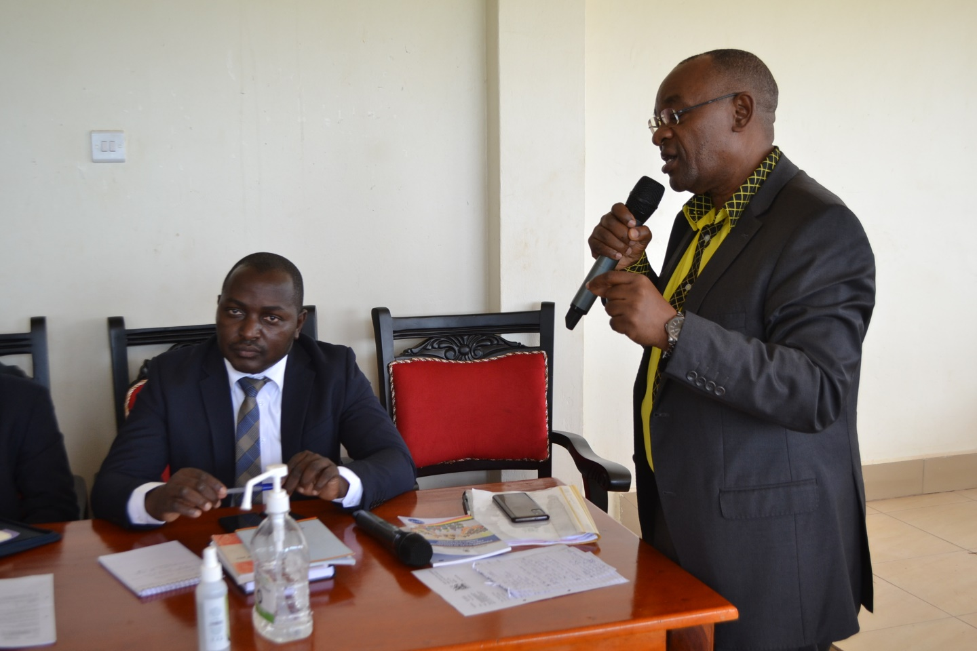

The Population has tremendously grown from 274,953 People according to the 2014 NPHC to 297,200 According to UBOS Mid 2023 Population Estimates.

PROGRAMME/SECTOR PERFORMANCES FOR FINANCIAL YEAR 2022/2023 – AND PRIORITIES FOR FY 2023/2024.
Mr. Speaker Sir, allow me to bring to your attention issues that have been brought to our charge and handled in the FY2022/2023;
GOVERNANCE AND SECURITY PROGRAMME

ADMINISTRATION

The following milestones were achieved in this Financial Year

Monitored and supervised departments, sub-counties and Town Councils in implementation of Government programmes and projects, Disseminated government policies and public information on government projects and programmes of Parish Development Model, UGIFT, among others, Initiated staff recruitment, placement and disciplinary actions, Undertook payroll management and control to ensure timely payment
STATE OF THE DISTRICT AFFAIRS
of salaries, pension, gratuity and emoluments and Procured Furniture for PAS and Human Resource Office.
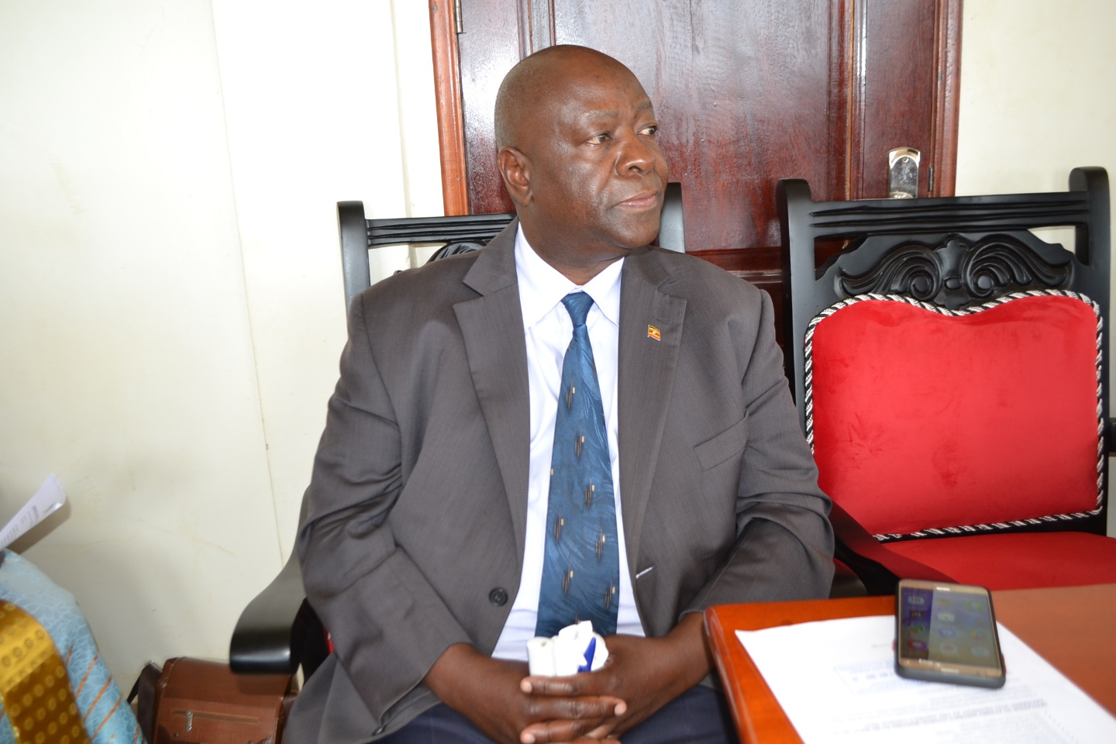
In FY 2023/24, the Department has planned the Following:
Conduct continuous trainings and mentoring of staff to improve efficiency and effectiveness in service delivery, monitoring staff performance to ensure timely delivery of key outputs and adherence to Government regulations and guidelines.
Monitor government programs and projects, payment of all utilities at the District and maintain security at the District, Carryout routine maintenance of the District website, provide high-speed internet services and disseminate public information to ensure good governance and accountability of public funds. The Department will ensure timely payment of staff salaries, pension and gratuity to gain confidence from staff, which improves staffs' well-being.
We will also complete the ongoing and external works on District Administrative block and coordinate the procurement of service providers and board of survey activities and Formulate and implement staff welfare policy to ensure employees’ wellbeing, interests, benefits, safety and the good of public image.
STATE OF THE DISTRICT AFFAIRS

STATUTORY DEPARTMENT (COUNCIL, BOARDS AND COMMISSIONS)
The 5th Council has registered the following achievements
Held 6 council meetings, 4 sets of Standing Committees, 8 District Executive Committees and 3 Business Committee settings, Paid sitting allowance and ex-gratia for District Councilors for the last eight months that is July 2022 to February 2023 and also paid for fuel for the District Executive Committee members, Speaker and Deputy Speaker and Passed the District Budget for FY2023/2024.
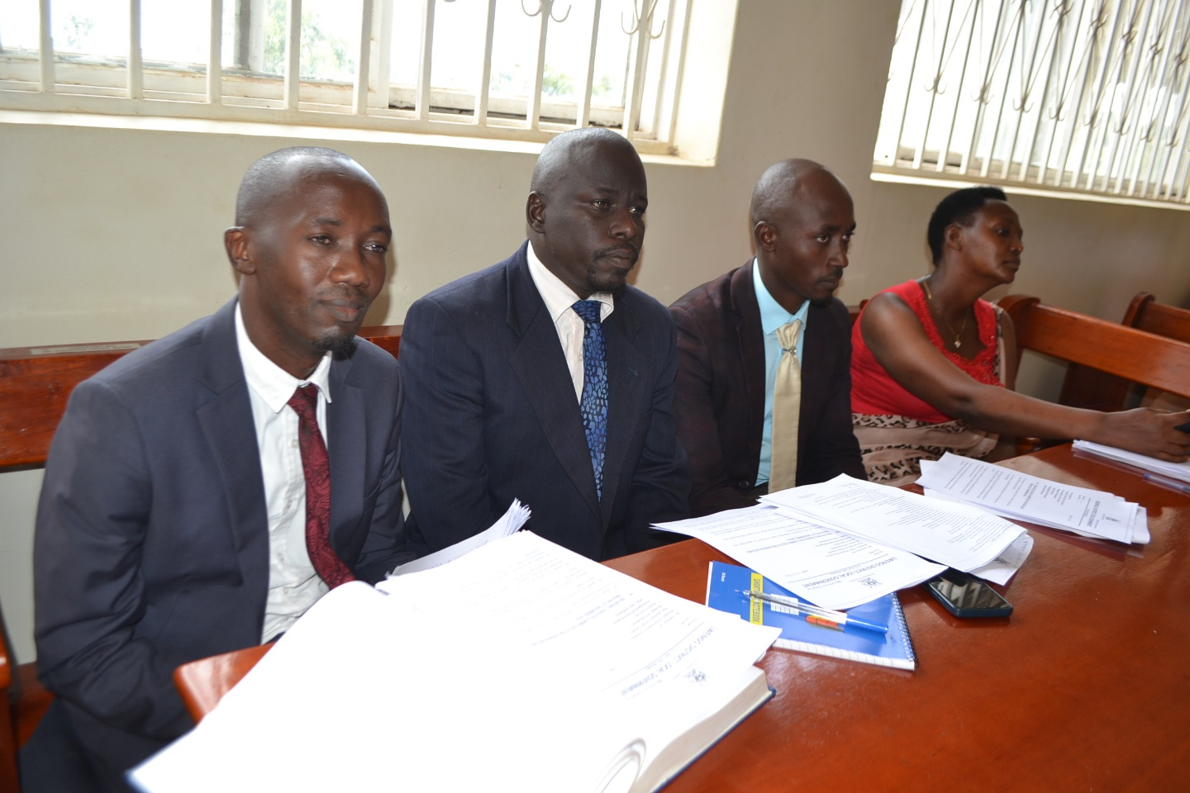
STATE OF THE DISTRICT AFFAIRS
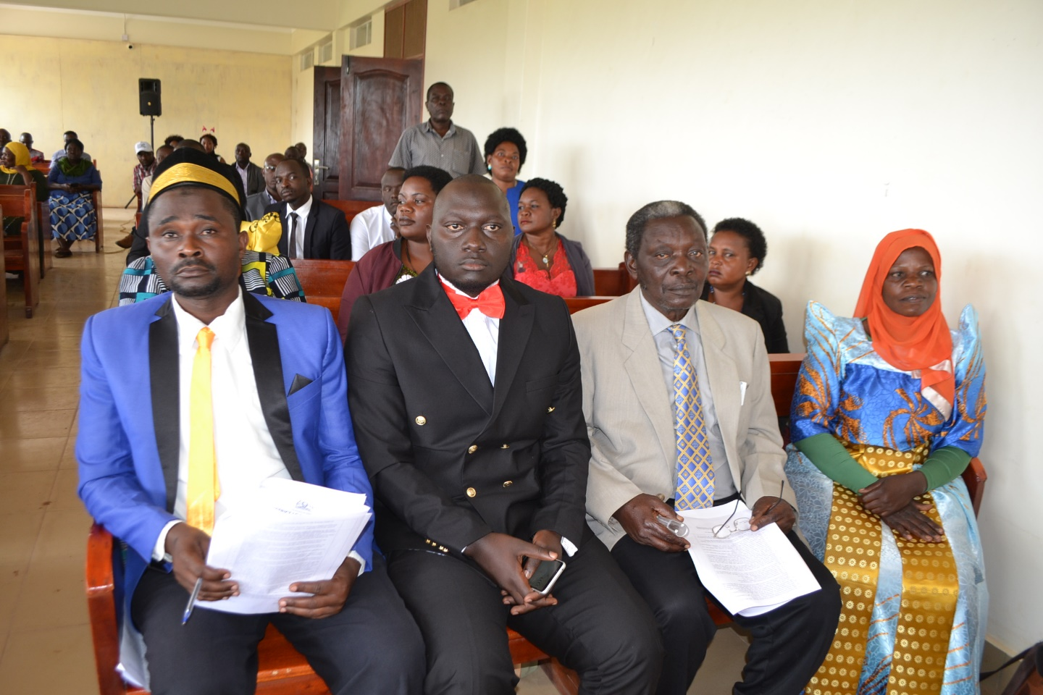

- District Service Commission
The Sector held 05 District Service Commission meetings where 60 appointments were made, 06 staff confirmed into their appointments, 01 regularization of staff appointment, 02 staff resigned from Public Service, 01 staff granted study leave, 01 staff granted leave without pay, 02 staff severely reprimanded, 01 staff reduced rank and 10 staff terminated on abandonment of duty.

- Contracts Committee/Procurement and Disposal Unit
Submitted before council the consolidated District procurement plan for the Financial Year 2022/2023 for approval and was subsequently approved and submitted to PPDA as the law requires, Prequalified 54-service providers for the FY 2022/2023, Awarded eleven contracts under open domestic bidding for works and supplies, 16 contracts under selective bidding, contracts for micro-scale irrigation systems to 8 beneficiaries and preparing the award of Contracts for Micro irrigation scheme to other 54 beneficiaries, Prepared and submitted 1st , 2nd and 3rd quarter FY 2022/2023 procurement reports to PPDA and other line Ministries in accordance with the law and Managed all IFMS Local Purchase Orders for fuel, supplies and contracted works.

In the FY2023/2024 Department Plans the following;
STATE OF THE DISTRICT AFFAIRS
To continue to Organize and conduct District Executive Committees, Sectoral Committees and Council meetings. Pay staff salaries, facilitate councilors with fuel and allowances for monitoring activities, prepare and submit PBS reports, work plans and budgets,

The District Service Commission, when fully composed, will handle appointments in the DSC, confirm staffs into their appointments, disciplinary control over staff, approve long term trainings of District staff and handle any submissions that might be presented to it.

Under the District Land Board, the Department will organize and convene land board meetings to handle land issues and conduct field visits to resolve land disputes.

Since for about 8 years, the district has failed to fully pay for additional land from Haj Kitatta and he has reclaimed it, I have directed that all un claimed land in Lwengo District that belongs to the Uganda land Commission (Public Land) should be claimed and applied for by Lwengo District and protected for future use for government projects starting with 89 Acres of land in Lwengo Town Council.

The Local Government Public Accounts Committee will organize and convene LGPAC meetings to review Internal, External Audit reports and any other special audit reports that will arise and make recommendations to the Chief Administrative Officer and District Council for implementation.
From the next Council meeting, recommendations of the LGPAC and Actions taken will form part of deliberations in Council.

Development Plan Implementation
INTERNAL AUDIT DEPARTMENT
The department performed the following activities;
Conducted audits for 4th quarter FY 2021-22,1st, 2nd and 3rd quarter for FY 2022/2023 for district departments, sub-counties, schools and Health facilities, Witnessed handing/taking over of Senior Assistant Secretaries, Town Clerks, Head teachers and Health In-charges, Conducted Audit of District payroll for the 1st, 2nd and 3rd quarter FY 2022/2023, Compiled a report to the Internal Auditor General Ministry of Finance, Planning & Economic Development about validation of Domestic Arrears as at 30th June 2022 and Carried out the verification report on actions taken by Accounting Officer on Internal Auditors report for FY 2021/2022 and submitted it to Internal Auditor General Ministry of Finance, Planning & Economic Development.
In the FY2023/2024, this Department will implement the following;
Conduct audit for District Departments, 6 Sub-counties, USE Schools, Health Centers and UPE Schools for 4th quarter FY 2022/2023, 1st, 2nd and 3rd quarter FY 2023-2024, Monitoring of projects implemented in the FY 2023/2024 such as Roads, Micro-Irrigation projects, water projects and carry out the verification reports on actions taken by Accounting Officer on Internal Auditor’s report and Auditor General reports.
STATE OF THE DISTRICT AFFAIRS

FINANCE DEPARTMENT
The Key achievements were;
Held Departmental meetings to discuss and analyse performance, challenges and strategies to improve on service delivery, Made consultations with the Line Ministry over various issues especially on IFMS, e-cash and cash limits, Invoiced and remitted funds for Lower Local Governments, USE, UPE, Technical as well as Health Centers, The Department also inspected projects to ascertain value for money both at Lower Local Governments and District, Prepared and submitted PBS reports for 1st and 2nd quarter FY 2022/2023, Filed statutory returns for PAYE and WHT for the period between July 2022 to February 2023, Followed up on Accountabilities for both staff and LLGs, Prepared and submitted Final Adjusted Annual financial statements for Financial Year 2021/2022 to Auditor General and Accountant General in accordance with the financial requirements, Monitored and supervised LLGs on revenue mobilization, Prepared and presented Draft BFP, work plans and budget for FY 2023/24 to committees for discussion and approval, Coordinated the External and Internal audits by providing all required information to the Auditors and Responded to queries raised by both Internal and External audit for FY 2021/2022 and the current year.
In the Financial Year 2023/2024, this Department will;
Strengthen and coordinate with development partners to ensure that their off-budget interventions are aligned to priorities in the five year development plan, developing an electronic revenue data base to ensure that all revenue sources are tracked and monitored at all Lower Local Governments and have a Master Data at the District. Comply with the existing laws and regulation relating to resource mobilization to improve Revenue performance and attract donor attention.
Under Budgeting, the Sector will work with the Planning Department in aligning IPFs with the planned activities linked to NDP III to ensure that we have a balanced budget. Conduct a mass awareness campaign through radio talk shows to mobilize the public and explain key priorities of the District in the District Development Plan, Budget Framework Paper, annual budgets and work plans. The Department shall also mobilize and engage Lower Local Governments in Data collection for preparation of BFP and work plans of Budget estimates for FY 2024/2025.
STATE OF THE DISTRICT AFFAIRS

PLANNING DEPARTMENT
The Department performed the following activities;
Coordinated the Preparation, compiled and submitted the PBS District Quarterly Performance Reports for FY2022-2023 for Quarter 1, 2 and 3, reviewed the LLG Development Plans, Organized the District Budget Conference for FY2023-2024
Coordinated the Preparation, compiled and submitted PBS District Budget Framework Paper, and District Draft Contract Form B for FY2023-2024, drafted the District Population Action Plan and prepared the District Statistical Abstract for 2022.
Coordinated Internal LGPA (Mock Assessment) for 2022, backstopped Assessments on the Implementation of DDEG in all LLGs, conducted the District Budget Conference for FY2023/2024, Drafted the District Family Planning Action Plan and District Statistics Strategic Plan, Held 10 monthly District Technical Planning Committee meetings, and supported the issuance of Birth Notifications in the District.

In the Financial Year 2023/2024, this Department will;
Hold one participatory planning meeting in each of the Lower Local Governments, coordinate 12 District Technical Planning Committee meetings with all Heads of Departments and Heads of Sectors, Prepare and submit quarterly and Annual PBS based Work plans and reports to Ministry of Finance, Planning and Economic Development, line Ministries and other stakeholders, Monitor the implementation of the 5 year approved DDP III, 5-year strategic plan for statistics and implemented government programmes, Acquire appropriate Spatial Planning Equipment like GPS machines and related work station equipment, Coordinate Internal Local Government Performance Assessment at sector and LLG levels and District Budget Conference for FY 2024/2025, Conduct annual performance review meeting at the District level, Supervise all Sectors and LLG AWPB to ensure they are aligned to the Five Year DDP and LLG DPs, Finalize and Operationalize the District M&E framework and train stakeholders in M&E tools, Prepare the District Statistical Abstract for FY 2023 and finalize and operationalize the District Population Action Plan, Coordinate Birth and Death Registration activities and Procure Office furniture to improve the working conditions of the planning department staff.

AGRO-INDUSTRIALISATION PROGRAMME
PRODUCTION AND MARKETING DEPARTMENT
The Department;
Held joint monitoring & commissioning with District Executive Committee, office of the District Internal Security Officer, Resident District Commissioner, Administration and some co-opted committee chairpersons. Participated in district Coffee Nursery verification exercise with UCDA regional officers, The Department conducted three Technical Supervisory visits, attended national & regional level extension workshops in greater Masaka and conducted a refresher training of departmental staff on Agricultural policies and new guidelines on farmer field schools at National Farmers Leadership Centre in Kampiringisa.
STATE OF THE DISTRICT AFFAIRS
On strengthening the Presidential campaign of promoting Parish Development Model, the Department conducted community meetings & facilitated other departments to carry out Annual General Meetings as stipulated in the PDM guidelines, Further to note Mr. Speaker, under Micro scale irrigation Program, the department sensitized and made farm visits to 40 farmers who expressed interest in water for production, To ensure the efficiency of this activity, 20 Farmer field schools have been established in 10 LLGs, The Department received 1,000,210 coffee seedlings and distributed to Lwengo district farmers who expressed interest, To ensure quality assurance in Fish management, the Fisheries sector enforced Fish Laws & regulations in Kyawagonya and Kyazanga. It also conducted 25 inspections of fish markets and one malpractice arrested in Kkingo, The department facilitated registration of 45 PDM SACCOs, 1 field day on bee keeping organized in Lwengo under Entomology Sector, Under animal husbandry, 75 trainings in livestock production and management were conducted, Disease surveillance, vaccination against PPR in goats and FMD in cattle, Routine meat inspection & new technology of artificial insemination in Piggery is on course, The sector also held three staff meetings to lay strategies on how to improve in animal quality and production, Recruitment of new Vet doctors in every LLG, To ensure increased production in animal production, 14 supervision visits and one Livestock capacity building training in rabbitory were conducted in the District that led to the vaccination of 50,000 birds, 565 dogs and 160 cats, Extension services provided in LLGs where 436 Agricultural Advisory services were delivered to farmers through 75 farm visits, 120 sensitization meetings, 260 trainings and 40 demonstrations, Conducted 20 monitoring and supervision of Agricultural extension activities by Sub county Leadership, Procured 3 motorcycles for extension staff of Ndagwe S/C, Kyazanga & Lwengo TC, Conducting a joint monitoring exercise in the district with Sectoral committee members and other stakeholders and Procured Office furniture (2 cabins, 3 office tables and 4 armed chairs).
STATE OF THE DISTRICT AFFAIRS
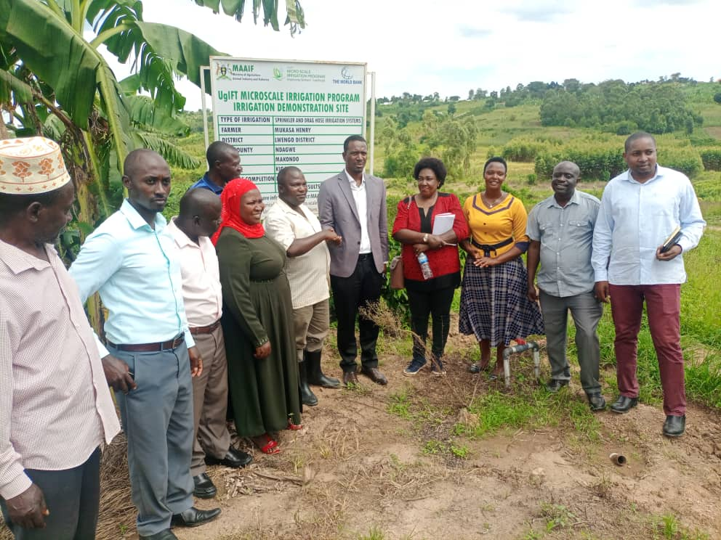

Commissioning of micro scale irrigation
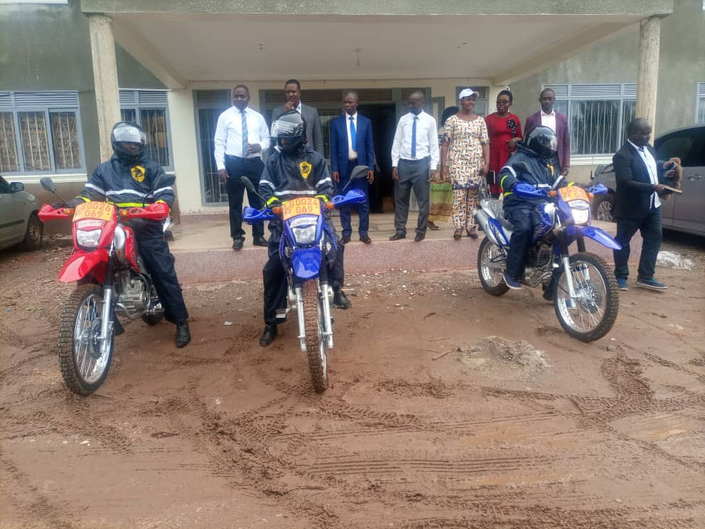
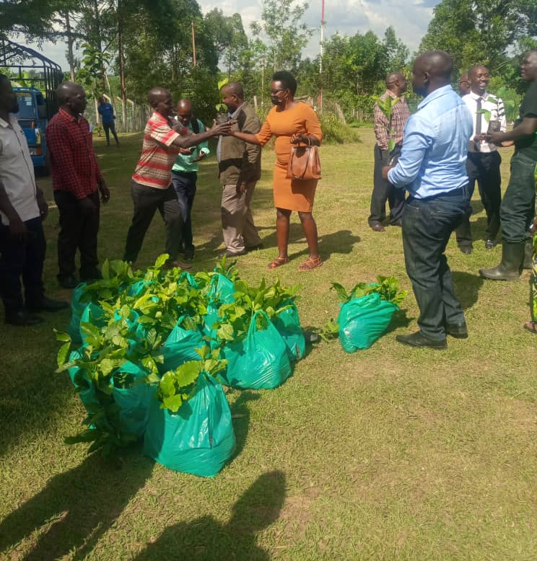

Distribution of Coffee seedlings from UCDA Distribution of motor cycles to extension staff

In the FY2022/2023, Production Department with all its sectors will;
STATE OF THE DISTRICT AFFAIRS
Mr. Speaker Sir, I would like to add that by the time of this address funds for extension grant, Micro scale Irrigation and Production both Development and Non-Wage had not been provided by the Centre.
Intensify control of pests/ parasites/ vermin and diseases of both crops and Livestock, Promote commercialized Agriculture through Parish Development Model and VAM, commercialization of agriculture and enforcement of quality assurance through inspection of crop nurseries, input dealer inspection, and other agro related inputs dealers, Give guidance and support to agro-processing (Bee farmers inclusive), control of pests like white flies through setting up of traps especially for fruit trees and for identification of tsetse flies and conduct continuous surveillance on crop and livestock diseases and pests in all sub counties, Procure Strichycline sulphate for destroying stray dogs and coordinate the vaccination of livestock on major diseases including local poultry and chicken, Establishment of management committees/ task forces for major crop and livestock diseases, Seasonal Collection of agricultural statistical data to guide, Promote and link farmers to research organizations for acquisition of most recent research developments, Identification and use of improved planting &breeding materials (AI, Clonal coffee, tissue culture banana, quick maturing Maize and bean varieties), Identification, mobilization, training and support to capable farmers for simple irrigation technologies/ schemes, Lobbying for heavy earth moving equipment for construction of water tanks and valley dams for livestock and simple irrigation, Promotion of water harvesting from roofs and run-off water for domestic use and production respectively, Empowering farmers with situational analysis demand articulation priority setting skills (participatory planning) that will guide farmers deal effectively with their immediate needs and hence appropriate demands in terms of services, technologies, information, and other relevant information, Identification and registration of agro-processing plants and promotion of more along the value chain, Establishment of market information system at lower local governments and the district, Mobilization and Organization of farmers into high level farmer organizations like producer and marketing groups and train them on group dynamics and leadership skills, Promotion of fish farming for farmers with water sources and those capable of harvesting water for fish farming, Promotion of use of high value inputs (fertilizers, pesticides, herbicides) for up scaling of enterprises of crop, livestock, fish and others, Identification and registration of farmer organizations and / or institutions and formation of farmer platforms along the value chain, so that they can benefit from service providers both public and private, Promotion of sustainable land management technologies like zero tillage, fertilizer use, soil testing, soil conservation structure establishment and Link farmers to research & other value chain actors; to increase farmer awareness on the existing improved technologies from research (NARO): - improved seed, artificial insemination, fertilizer, insecticides, soil & water conservation, climate smart agriculture; appropriate technical skills like post-harvest handling, value addition to mention a few.

STATE OF THE DISTRICT AFFAIRS

HUMAN CAPITAL DEVELOPMENT

EDUCATION AND SPORTS DEPARTMENT
The Department has so far achieved the following;

Enhanced support supervision of schools where all schools in the District were reached at least once, Remarkable progress in PLE performance where first Grade increased by 16.6 % Capacity building to schools management committees and Head teachers, Participated in National games and sports competitions (Athletics, Ball games and Girl guides), Team building in Education department at the District Head Quarters,
Constructed a two classroom block, office and store at Kagoogwa P/S in Kyazanga S/C, Constructed a two classroom block, office and store at Balimanyankya P/S in Lwengo S/C, Constructed a two classroom blocks, office and store at Kiwangala P/S in Kisekka S/C, Launched the construction of Katovu seed sec school, Commissioned the SFG Projects with the District Executive Committee and RDC and Constructing a two classroom blocks, staff house and 2-5 stance lined VIP latrine at St Jude P/S Kyazanga.
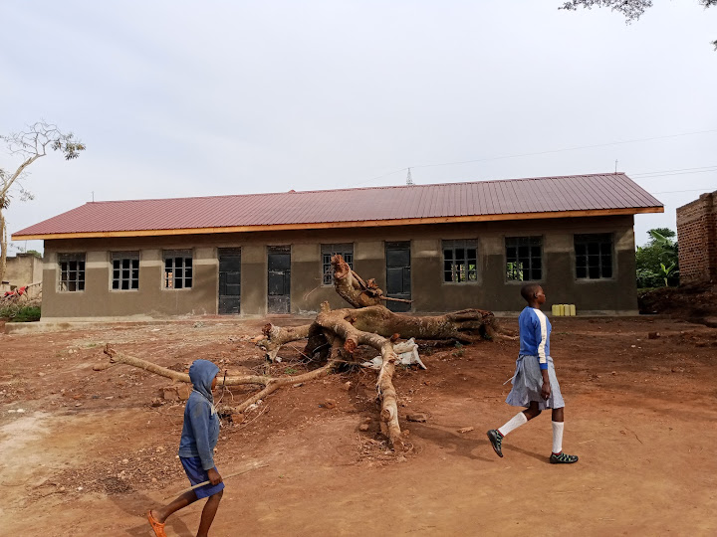
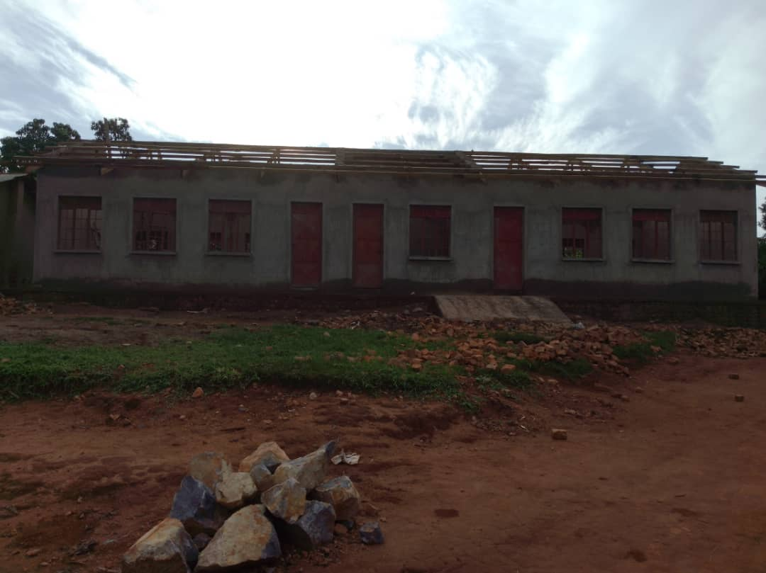
Two classroom block, office and store at Two classroom block, office and store at
Balimanyankya P/S in Lwengo S/C. Kiwangala P/S in Kisekka S/C.
STATE OF THE DISTRICT AFFAIRS
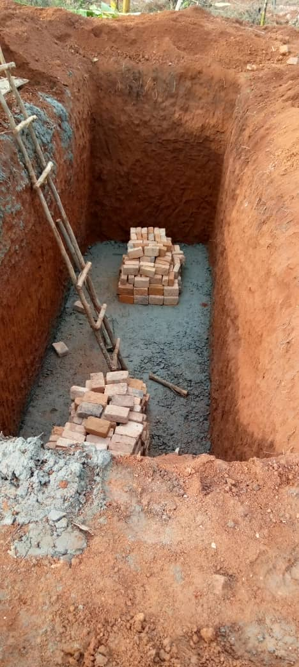
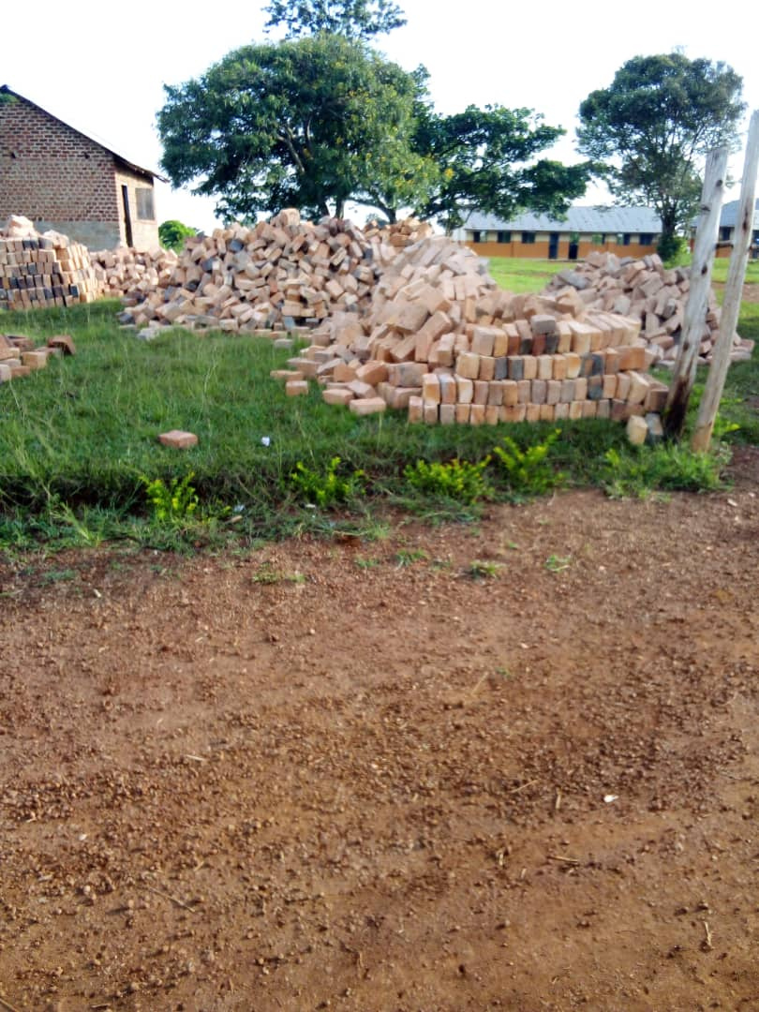

Ongoing construction works of 5 stance lined latrine at Bigando P/S `
In the Financial Year 2023/2024, Department will;
On Development expenditures;
The department will construct a 3 classroom block at Lyakibirizi cope P/S in Kyazanga S/C, a 2 classroom block with an office space and store at St Paul Jaga P/S in Ndagwe SC, Lwensambya P/S in Malongo S/C, and Namisunga Madarasat in Lwengo SC, Construct 3-5 stance latrines at Kanoni P/S in Kyazanga S/C, St Joseph Kinoni P/S in Kinoni TC and Nakiyaga P/S in Lwengo S/C under SFG, Completion of Katovu Seed Sec School.

On recurrent expenditures, the department will pay staff salaries, inspect, monitor and supervise Government and Private Institutions, Disburse capitation grant to Primary, Secondary and Tertiary institutions, Organize Sports and Co-curricular activities at School and District level, Promote Special Needs Education in the District, Coordinate Mock and PLE activities in all Government and Private schools and prepare, share and Submit reports, budgets and work plan to respective line Ministries, The Department will also mobilize communities on enrollment of learners, train Head teachers on Management of schools and conduct meetings for head teachers and other stakeholders, Appraise teachers, process teacher’s files for confirmation and approve performance agreement and performance assessment of head teachers, Provide SNE support to teachers and learners, Gender mainstreaming in Bukoto Midwest and Retreat for education staff and social services.

STATE OF THE DISTRICT AFFAIRS

HEALTH DEPARTMENT
In FY2022/2023 the Department;

Renovated of Kyazanga HC IV staff house, Fenced of Kyetume HC III, Renovation of Lwengenyi HC II staff house, The Upgrade of Lwengenyi from HC II to HC III is ongoing, Fenced of Kinoni HC III, Procured of Medical equipment for Kakoma HC III, The Department held 08 District Health Team meetings focusing on health service delivery, 02 extended District Health Management Team (EDHMT) meetings, Conducted 03 integrated support supervisions, drugs & medical supplies and held 07 health education talk shows (community and radio), Coordinated COVID-19 response activities in all health facilities in the District by creating additional vaccination centers to bring services near to the community and Development Partner activities across the District and engaged in launching, monitored & supervised all development projects for Renovation of Lwengenyi HC II & Kyazanga HC IV staff houses and fencing of Kyetume and Kinoni HC III.

The Health Sector in the Financial Year 2023/2024 will;
Pay Staff salaries and PHC direct transfers to facilities, Prepare monthly, quarterly & annual HMIS reports, conduct DHT integrated support supervision/political monitoring and MCH support supervision, Hold quarterly performance review meetings, monthly DHT meetings and quarterly EDHMT meetings, Conduct malaria prevention, control and management activities, HIV prevention & care activities and voluntary medical male circumcision activities, Coordinate Yellow fever vaccination, cervical cancer immunization activities and routine screening for non-communicable diseases (hypertension, diabetes), Conduct supply chain management trainings, continuous quality improvement at District and health facility level, VHT trainings, routine immunization activities, family planning activities, covid-19 response and other epidemic response activities, On cross cutting issues, the Department will support Gender and Community Development and Natural Resource Department in male engagement about family issues to reduce on gender based violence issues and screening and monitoring of development projects respectively.

On Development activities, the Department will upgrade Kisansala from HC II to HC III, Expand and renovate the maternity ward at Naanywa HCIII and construct staff Houses at Lwengenyi HC III, Renovate a staff house at Kyazanga HC IV, construct a 5-stance pit latrine at Naanywa HC III and install main and minor gates at Kyetume HC III.

INTERGRATED TRANSPORT PROGRAMME
ROADS AND TECHNICAL WORKS
Mr. Speaker Sir, the Works and Technical Services sector covers the areas of Roads, Housing, Mechanics and Electricity. Under the Works and Technical Services sector, the following are completed and ongoing projects;
Maintenance of Nkoni-Nzizi Road (7.9km) Spot gravelling on Kyogya-Kibaale-Kinoni Road (4Km) Maintained of Kinoni-Nakalembe Road (3Km), Grading of Katovu-Kaikolongo Road (8km) Maintained Kitooro-Ndagwe Road (9km) at a cost of shs Maintained of Kitooro-Ndagwe Road (9km Maintenance of Lwempazi-Busibo Road (6Km) (work on going), Supply and installation of culverts on the following roads; Lubaale-Kiteesa-Ssekyondwa(6), Kyawagonya-Kyetume-Bugonzi(6), Nkoma-Lwempazi(6), Kalyamenvu-Busibo(6), Lwentale-Kyampalakata(6), Kinoni-Kisseka(6), Kyantale-Kyasa (6),Mpumudde-Kakiraga (6), Kinoni-Nakalembe (6), Lwemiyanga A (6), Kitongole-Lwendezi(6), SSeke Road(6), Nakatete-Buzinga(6), Kyamaganda-Ngereko(6) and Lwengo-jjaga-Ndagwe(12) and Routine labor based of Kaweesi Road
STATE OF THE DISTRICT AFFAIRS

Had Operational costs include; Repaired and serviced of road equipment, facilitated Road committee sitting and prepared reports and accountabilities
Did Routine Labor Based for district roads (205 KM)

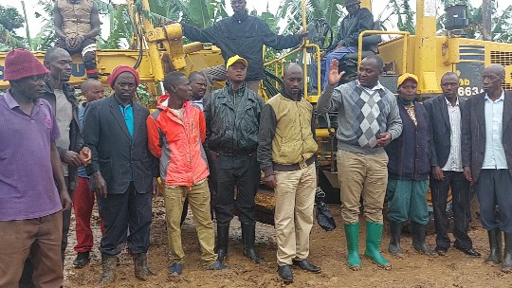
STATE OF THE DISTRICT AFFAIRS
LIST OF ROADS TO BE WORKED ON IN THE FY 2023/2024

 | Road Name | Length (km) | Surface Type | Location/Sub-county name | Budgeted amount
1 | Kafuzi – Nakyenyi – Lwengo Road | 10 | Gravel | Lwengo S/C in Bukoto County | 923,490
2 | Kinoni – Kyamaganda – Kisekka Road | 8.6 | Earth | Kisekka S/C in Bukoto County | 794,202
3 | Makondo – Micunda – Lwengo Road | 12.5 | Earth | Lwengo S/C in Bukoto County | 1,154,363
4 | Nkoni – Nzizi | 7.9 | Earth | Kkingo S/C Bukoto County | 729,557
5 | Katovu – Keikolongo Road | 8 | Gravel | Malongo S/C | 738,792
6 | Kitooro – Keikolongo Road | 6.9 | Earth | Malongo S/C | 637,208
7 | Kitooro – Buyinja – Ndagwe Road | 20 | Earth | Kyazanga and Ndagwe S/C | 1,846,980
8 | Kitooro – Kamiti – Katuuro Road | 13 | Gravel | Kyazanga S/C | 1,200,537
9 | Kyetume –Lwamanyonyi – Kakoma Road | 12 | Earth | Kisekka S/C | 1,108,188
10 | Kinoni – Nakalembe – Kibulala Road | 3 | Gravel | Kisekka S/C | 277,047
11 | Birekereawo Road | 11 | Earth | Kisekka S/C | 1,015,839
12 | Kyalubu – Serinya Road | 3.5 | Gravel | Kkingo S/C | 323,222
13 | Nakyenyi-Nsonja-Bulasana | 6.5 | Earth | Kkingo S/C | 600,269
14 | Katovu – Kyampalakata Road | 8 | Earth | Malongo S/C | 738,792
15 | Ndagwe –Jjaga – Lwengo Road | 15 | Earth | Lwengo and Ndagwe S/C | 1,385,235
16 | Luti – Buswaga – Ndeeba Road | 7.5 | Gravel | Lwengo&Ndagwe S/C | 692,618
17 | Mbirizi – Nakyenyi – Bulasana Road | 11 | Gravel | Lwengo S/C | 1,015,839
18 | Bulasana – Misenyi – Kibuye Road | 7.5 | Earth | Lwengo&Ndagwe S/C | 692,618
19 | Kaapa-Kibingekito | 10 | Earth | Ndagwe S/C | 923,490
20 | Kalyamenvu-Busimbi | 8 | Earth | Kyazanga | 738,792
19 | Kyalutwaka – Kalisizo Road | 6.5 | Gravel | Lwengo S/C | 600,269
20 | Bijaaba – Busumbi – Kakoma Road | 12 | Earth | Kyazanga S/C | 1,108,188
21 | Buzinga – Bukumbula-Kanku Road | 8.5 | Earth | Kisekka S/C | 784,967
22 | Kakoma – Nkundwa Road | 6.5 | Earth | Kyazanga S/C | 600,269
23 | Kizimiza – Kengwe – Kiteredde – Kiwogo Road | 12 | Earth | Kyazanga S/C | 1,108,188
24 | Kakoma – Bakijjulula – Kitwe Kyanjovu Road | 7.3 | Earth | Kyazanga S/C | 674,148
25 | Nkoni – Nabyewanga – Bwasa Road | 4 | Earth | Kkingo S/C | 369,396
26 | Kalyemanvu-Kamuwaza-Kikanika | 12 | Earth | Kyazanga S/C | 1,108,188
27 | Rwenkakala – Kyamatafaali – Kakiraga Road | 5 | Earth | Ndagwe S/C | 461,745
28 | Kyantale – Kyasa – Rwebisunsa Road | 9 | Earth | Ndagwe S/C | 831,141
29 | Kyetume – Kalagala – Mayira Road | 15.2 | Gravel | Lwengo S/C | 1,403,705
30  STATE OF THE DISTRICT AFFAIRS | Nkalwe-Kabwami – Mitimikalu Road | 6 | Earth | Kkingo S/C | 554,094
31 | Kitooro – Lusaka Road | 9.2 | Earth | Kyazanga S/C in Bukoto county | 849,611
 | Total | 303.1 |  |  | 27,990,987

Routine Mechanized Road
Road ID | Road Name | Length (km) | Surface Type | Location/Sub-county Name | Rehabilitation
2 | Kinoni – KakingaNkunyu Road | 9.2 | Earth | Kisekka&Lwengo S/C
14 | Nkoni-Kinsasala-Ngondati | 6.5 | Earth | Lwengo S/C
15 | Lwentale-Kyampalakata-Mudaala | 24 | Earth | Malongo S/C
16 | Busubi Kiswera Kigaba
17 | Kyawagonya Rwamanyonyi
18 | Lwebisisi Kigeye Nyantungu
19 | Kamazzi Malongo Piida
20 | Jagga kankanda Piida
21 | Lwentale Kyapalagata Mudaala
22 | Bwingana Kagaaga Kawule
49 | Total | 144.4 |  |  | 1,000,000,000

The Department will also repair vehicles and Road equipment, prepare bills of quantities and specifications for all contracted projects for FY 2023/2024, pay staff salaries, conduct quarterly road committee meetings, supervise and monitor contracted works for both Higher and Lower Local Government and prepare quarterly accountabilities and Prepare and submit departmental annual budget and quarterly reports to Uganda Road Fund and other line Ministries.

NATURAL RESOURCES, WATER AND CLIMATE CHANGE
WATER
Water Department
This Sector Mr. Speaker Sir, is mandated to provide the people of Lwengo District with clean and safe water through mobilization and sensitization of communities on aspects of water and sanitation, construction and protection of safe water sources in order to increase safe water coverage and improve the level of hygiene and sanitation.
STATE OF THE DISTRICT AFFAIRS
Mr. Speaker Sir, to ensure the attainment of the above mandate, the following are completed and ongoing activities;
Sn | Key output | Activities | Location/  Sub county
1. | Construction of public Latrine in RGCs | Agreement signed for 5 stance lined latrine. | Katuulo (Kyazanga S/C).
2. | Spring Protection | Masonry tanks and springs Agreement signed. Actual works commencement for  50M³ at 00% | -Mbirizi Seed Sec School (Lwengo TC)  -St. Charles Lwanga Kensenene (Malongo S/C)  -Busumbi P/S (Kyazanga S/C)  -Mastered seed Nursery and P/S Kiwangala (Kisekka S/C)
2. | Spring Protection | Masonry tanks and springs Agreement signed. Actual works commencement on for 30M³ at 00% | St Peters Kawule P/ school (Malongo S/C)  -Naanywa HCIII (Ndagwe S/C)
3. | Borehole drilling and Rehabilitation. | Geological survey and actual drilling on to achieve the required water potential at 50% | -Kyekulura (Kisekka S/C)  -Kabwami (Kkingo S/C)
4. | Purchase of borehole spares | Rehabilitation of water sources in the entire district at 45% | Delivery of spares to respective sites is delayed by departmental vehicle, which still lacks tyres and mechanical repairs from service provider.
5. | Construction of piped water supply systems. | Nkunyu-Mayiira Mini solar motorized is at 70% complete. | Nkunyu-Mayiira (Lwengo S/C)
6. | Construction of Valley Dams. | Nakalago-Kyazanga 60% Complete. | Nakalago (Kyazanga S/C)
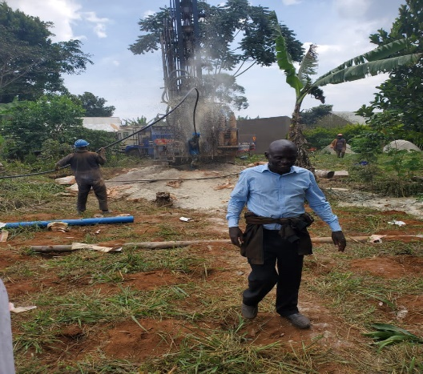
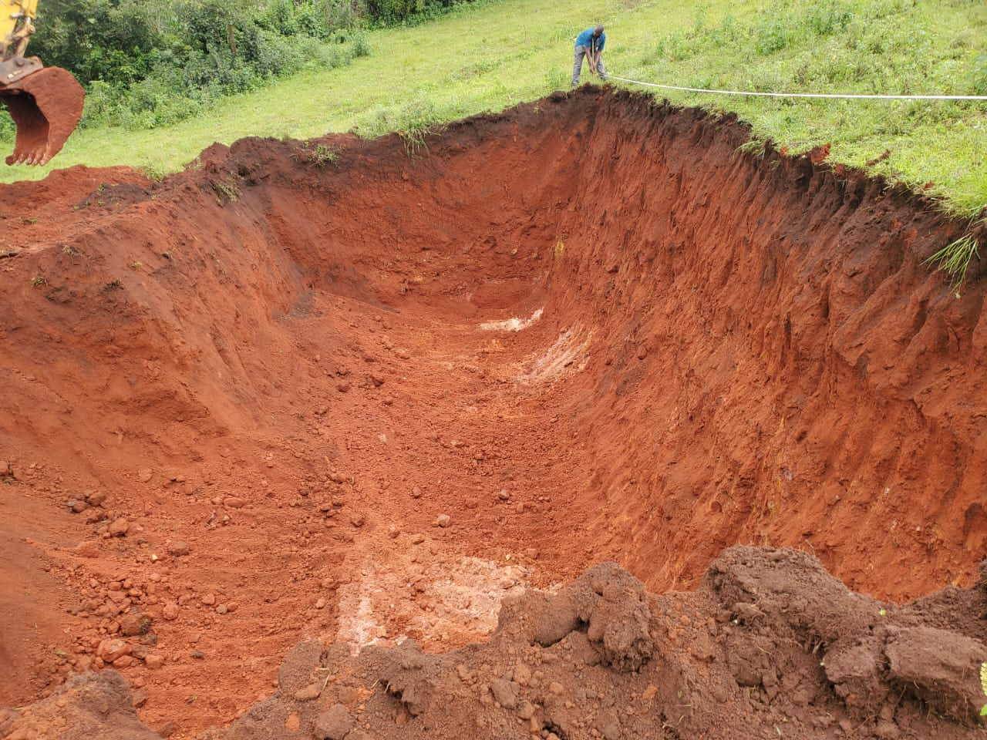
STATE OF THE DISTRICT AFFAIRS

Borehole Drilling at Kyekulura Kisekka S/C Valley Tank works at Nakalago Kyazanga S/C
In the FY2023/2024, The Water Department will implement the following activities;
Coordination of stakeholders to receive new facilities and Non-Government Organizations in water service, Repairs and purchases of office equipment for District Water office, General operation costs of District water office, Monitoring and supervision of new and old water sources in the District, Operation and Maintenance of urban water facilities constructed in the previous 3 years, Community mobilization to co-funding, management committees to water sources and trainings.

Development activities
Construction of one Sanitation facility (5-stance latrine) in Malongo S/C, Construction of water supply facilities Rainwater harvest tanks of 4-50M³ in Malongo, Kkingo and Ndagwe sub counties, Construction of 2-30M³ masonry tanks at schools, Drilling and installation of Deep Borehole/Production wells, Construction of a piped water supply system in Kyazanga S/C, Construction of 2 new 3000M³ Valley tanks in Lwengo and Ndagwe sub counties, Purchase of Borehole spares and mini solar system and Payment of retention for previous year 2022/2023 projects.

NATURAL RESOURCES
.Under this sector, the following were achieved;
The sector has registered achievements in the areas of climate change response, wetland management and restoration as well as introducing participatory approaches that aim at reversing the trend of loss of bio diversity in the district. Mitigation and adaptation technologies are being mainstreamed in projects and programmes of both State and non-State Actors. However, there still exist challenges that continue to threaten the district’s environment and natural resource base
Restoration of fragile ecosystem
Lwengo district has basically two fragile ecosystems, these include wetlands and bare hilltops. Wetlands in the district cover approximately 10% of the total land area. There has been wetlands inspections, monitoring and subsequently issuance of wetland improvement Notices to over 400 encroachers in Lwengo S/C (Mayira, Nkunyu and Kyanjovu Wetland), Kisekka S/C, Kkingo S/C (Kisansala- Ngondati and Nakatooke-Bigando wetlands) and Ndagwe S/C, carried out follow-up activities such as training and awareness creation of communities with substantial encroachment (Bulimbale Dam wetland and Kakukuulu wetland in Malongo S/C), inspections of sub counties environment management initiatives, cautioning of the culprits and giving them some grace period to harvest their produce, Demarcation inspection of a 50km stretch at Kiyanja- Kaku wetland in Kyazanga T/C and Lwengo sub-county which was done in 2021/2022 amidst challenges of protests by the community. Sensitizations were done but political actors politicized the process. Over 1000 bamboos were uprooted by the communities.
STATE OF THE DISTRICT AFFAIRS
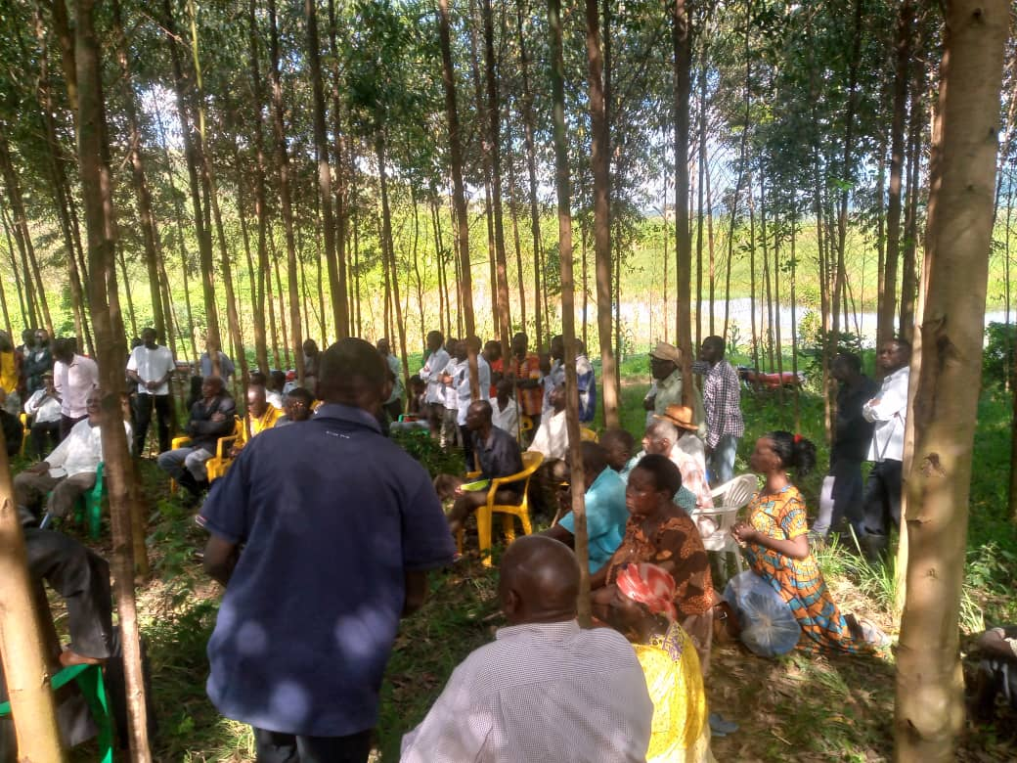
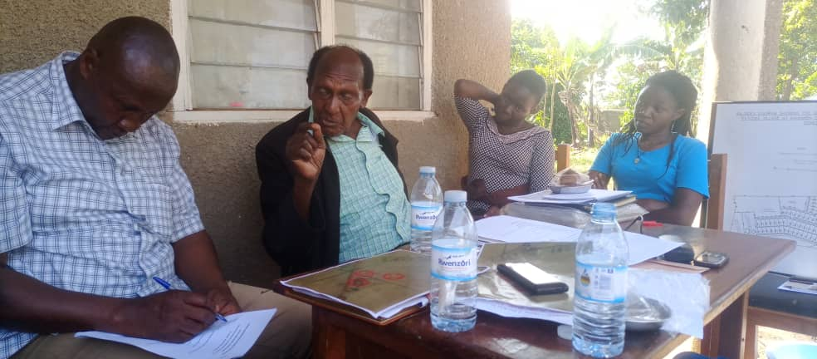
Sensitization at Bulimbale Dam District Land Team discussing MOU with by Environment Management Team Hon. Bazira Ssewanyana who donated land at Kamazzi for construction of HC III
Land management services
Embarked on Mass land registration in Kyazanga T/C, Kyazanga S/C and Malongo S/C. Over 350 titles have been completed and issued to owners, 50 are still in process and about 25 unclaimed.

The district had put aside ten million for payment of Land (Hajji Kitatta). Unfortunately, we are too late. Let us use this money to secure land from the Uganda Land Commission.

We have embarked on registration of land at Katovu TC seed school and Katovu HC IV upgrade at Kamazzi which was donated by Hon Henry Bazira Ssewanyana.

On physical planning, 3 Physical Planning committee meetings have been held, 2 Land Board meetings have been held and over 30 developers have been guided on new development. Participated in all Town Council Physical planning Committee meetings, 34 land inspections done and twelve million shillings was collected under local revenue. 25 dispute resolutions handled and 12 disputes resolved so far. However, the District has no functional Land Board hence affecting Land management processes in the district.
Forestry and tree planting
Activities done were inspection and patrolling for illegal forest activities, revenue collection where about shs 1,500,000 has been collected, advised and trained 68 farmers on tree planting and agro-forestry management. However, having majority of farmers dealing in coffee, agro-forestry has been resisted due to prevalence of the coffee twig borer. Inspected and trained nursery operators in 11 locations and We set up 5 demonstration plots for Clonal Eucalyptus at the district, in Malongo, Kyazanga and Lwengo sub counties and procured a laptop for the department.
Oil and gas
The district is being crossed by the Oil pipeline, in this respect therefore, we have had sensitizations in various fora about the resource and how the mid-stream actors can benefit. So far compensation is about 85% complete, re-settlement action plans are being implemented by constructing houses for PAPs and training of the Youth of PAPs in tailoring, welding and catering at St Charles Lwanga technical institute Butende and Mummy's technical institute at Nyendo Masaka, Titling process of the right of way and issuance of Vacation Notices has also commenced and Training of potential suppliers of goods and services in business management skills is ongoing at Mbirizi Catholic Church.
STATE OF THE DISTRICT AFFAIRS
Partnerships with other Organizations
The district is partnering with ICF, Nature Uganda to cater for wetlands and Crane conservation in the District. We celebrated World Wild life day at Kasambya P/S in Ssembabule district where the Tourism section represented the district. Among the activities conducted by the Partnerships include but not limited to; income generating activities in poultry/piggery, training in agronomic practices on wetland banks/wetland edge farming. The department also trained two staff in scientific wetland assessment and sensitized on wetland/crane conservation, monitored crane nests in Birunuma, Kirumba and Kyakabandagala among others.

Land management services
Embarked on Mass land registration in Kyazanga T/C, Kyazanga S/C and Malongo S/C. Over 350 titles have been completed and issued to owners, 50 are still in process and about 25 unclaimed. The district has released ten million for payment of Land (Hajji Kitatta); we have embarked on registration of land at Katovu TC seed school and Katovu HC IV upgrade at Kamazzi, which was donated by Hon Henry Bazira Ssewanyana.

Physical planning, 3 Physical Planning committee meetings have been held, 2 Land Board meetings have been held and over 30 developers have been guided on new development. Participated in all Town Council Physical planning Committee meetings, 34 land inspections done and twelve million shillings was collected under local revenue. 25 dispute resolutions handled and 12 disputes resolved so far. However, the District has no functional Land Board hence affecting Land management processes in the district.
Natural Resources
In the FY2023/2024, The Department will implement the activities summarized below;

Titling of land in at least 5 government institutions especially at health centers and education facilities, Demarcation of 100km stretch of wetland in Kkingo, Malongo, Ndagwe, Kisekka and Kyazanga sub counties, Sensitizing of 200 local stakeholders in conservation activities, Screening, inspection and certification of at least 30 projects in next Financial Year for environmental compliance, Participation in oil and gas activities most especially monitoring RAP and construction activities for social and environmental safe guards, Registration of at least 50 parcels of land in the District for private persons.

STATE OF THE DISTRICT AFFAIRS

COMMUNITY MOBILISATION AND MINDSET CHANGE
GENDER AND COMMUNITY BASED SERVICES
The Sector achieved the following;
STATE OF THE DISTRICT AFFAIRS
Supported the implementation of YLP program. Total amount so far received since the start of the program in 2014, is shs 1,001,733,950 in 134 groups with 1,506 (816 male and 690 female) beneficiaries; and shs 217,383,500 has been recovered, supported the implementation of UWEP program. Total amount of UWEF so far received since 2016/17 is shs 656,418,069 in 95 women groups with 1,009 beneficiaries. Shs. 189,298,200 has so far been recovered, supported the implementation of PCA Model in 26 parishes with 5,798 males and 3,796 females in 503 Community Groups. Have so far received shs. 810,000,000 under the programme as detailed below; Number of PCAs supported: 10 PCAs in 2018/2019,05 PCAs in 2019/2020, 06 PCAs in 2020/2021, 06 PCAs in 2021/2022,Received and handled sixteen social conflicts under the probation office; one was, referred to Court, two to FIDA and the rest were reconciled, 14 cases were received by Lwengo legal aid clinic coordinated by FIDA Uganda and 100% of them have been concluded through mediation and counselling, 9 cases of GBV were received by OKOA Refuge center in Mbirizi, 4 Juvenile offenders were represented in courts of law and social inquiries made on each, Conducted quarterly review meetings for all social protection committees with support from MADDO who are working with OVC, 3 GBV follow-up visits to resolve family conflicts conducted, 12 Department staffs monthly salaries validated and paid, Key planning activities especially under PDM enhanced, monitored and support supervised, 4 missing children resettled with their families by the district probation office, 10 sector staff supported to implement, monitor and support supervise PDM activities at Parish level, Supported the Youth Council, Women, Disability, and Old persons' Councils to conduct District Executive meetings, Supported the commemoration of the international day for older persons, Mobilized for the payment of Older persons under the SAGE program, 020/2021, 06 PCAs in 2021/2022,
Received and handled sixteen social conflicts under the probation office; one was referred to Court, two to FIDA and the rest were reconciled, 14 cases were received by Lwengo legal aid clinic coordinated by FIDA Uganda and 100% of them have been concluded through mediation and counselling, 9 cases of GBV were received by OKOA Refuge center in Mbirizi, 4 Juvenile offenders were represented in courts of law and social inquiries made on each, Conducted quarterly review meetings for all social protection committees with support from MADDO who are working with OVC, 3 GBV follow-up visits to resolve family conflicts conducted, 12 Department staffs monthly salaries validated and paid.

In the FY 2023/2024 the Department will accomplished the activities below;
Respond to Gender mainstreaming through Support to GBV activities and Gender audit in development programs, Provide inspection, monitoring and Labor Management services by supporting labor based institutions' support supervision and monitoring, arbitration and follow up of completed labor conflicts, Promotion of Arts and Crafts by supporting community sports and local creative Artists and positive cultural advancement, Respond to HIV/AIDS mainstreaming by conducting sensitizations on HIV/AIDS prevention and fighting stigma within communities, Promotion of proper implementation of PDM and all other government programs by supporting monitoring and support supervision of sector programs, projects and activities, Provide Capacity Development services through support to retreats and study Tours for both political and technical staff, Support to special interest groups by supporting Women, Youth, Disability and Old persons Councils' activities and provide social rehabilitation services to PWDs, To provide Community mobilization and empowerment Services by facilitating Community Development Workers to implement sector programs, projects and activities and provide support to Parish Community Associations (PCA) under Luwero/Rwenzori Project. And also shall support community mobilization for participation in integrated community learning and wealth creation program (ICOLEW), Promote Social protection and empowerment by supporting the provision of Probation and social welfare services.

PRIVATE SECTOR DEVELOPMENT, MANUFACTURING AND TOURISM DEVELOPMENT

COMMERCIAL SERVICES
Trade and Industry department has achieved the following in FY2022/2023;
3 Sensitization meetings were held in Katovu, Nkoni and Ndeeba trading centers on record keeping and compliance issues, Inspected and supervised businesses in Kinoni and Lwengo Town councils especially on locally produced (beverages) and counterfeit products, Inspected 35 businesses/enterprises in the district towards compliance with the existing laws including existence of the counterfeit, uncertified and expired products on the market, Monitored and guided 53 Emyooga SACCOs and 15 ordinary SACCOs on portfolios management especially loans, 45 PDM SACCOs leadership committees formed and trained in their roles and responsibilities, Back stopped Kyazanga Modern P/S SACCO and assisted to attain permanent registration, attended Commercial officers meeting in Arua and AGMs for LWEDE and Kinoni traders and farmers SACCOs, and Nkoni coffee farmers’ cooperative society among others, Prepared and shared Market Information Report with the line MDA, Inspection and backstopping of the hospitality facilities operators conducted, Sector reports including 4th quarter 2021/22, 1st quarter 2022/23 performance, routine reports among others were prepared, shared with stake holders and submitted to line MDA.
In the FY2023/2024, the Department of Commercial Services will the following activities.
Private sector Department
Pay Staff salaries, Facilitate technical personnel to prepare share reports and attend sector related meetings/conferences, Monitor and conduct BDS for SMEs, Facilitate the formation and strengthening of cooperatives and trade associations in the District, Support and strengthen the cooperatives to create employment and wealth through collective production, bulking and marketing of farmer produce and bi-products- say under Emyooga and PDM SACCOs among others, Take advantage of free Government media airtime to publicize and popularize PDM and Emyooga for cheaper Capital, Organize dialogues between the public & private sectors on improving economic environment, trade policies and regulations, Reduce the cost of doing business and harmonizing between the trade regulations and promotion of revenue collection, Address non-tax barriers in doing business, Market linkage services provided through collection and sharing, increase consumption of local goods and services (BUBU) through reservation and adequate display of local products on shops/supermarkets (50%) shelf space, Institutionalize the LED Model (LED Forum ,LED Technical committee) for public-private engagement and planning.
STATE OF THE DISTRICT AFFAIRS
Manufacturing sector
Sensitization of Industrialists on quality standards and quality assurance aspects, Identification of Value addition potentials in the respective parishes, SMEs database created, updated and shared, Compliance to industrial policy and other regulations related to industrial developments for sustainable industrialization.
Tourism Development
Tourism hospitalities in the District monitored for compliance and Hospitalities owners and operators backstopped in BDS

MAIN CONSTRAINTS TO SERVICE DELIVERY
Failure to collect Local Revenues as planned especially because of on-going effects of Covid 19 Pandemic and quarantine on movement of animals, Lack of transport for revenue mobilization, supervision and monitoring of recurrent and development activities both at District and sub county level, Lack of institutions like babies’ remand homes and rehabilitation centers in the district, High financing costs on management of Juvenile offenders from police and court to the remand home in Kampala, Many Elderly persons are so weak and fragile that fail to reach the pay point. The few who reach the pay points are usually disgusted with the slow and clumsy processes involved, Low adaptability to compliance due to mindset issues, Governance Challenges in some Cooperatives esp. Emyooga, High Default rates in SACCOs due Covid19 effects, Cooperatives with expired certificates operate under inadequacy enforcement of regulations among the key players like office of RCS, SMEs with uncertified products are on increase, Animal theft and stray dogs is very high in the community especially in Kyazanga, Malongo and Kisekka Sub Counties, African swine fever outbreak across the District, which leave our piggery farmers in a miserable state, Failure by most District Stakeholders to appreciate and participate fully in planning issues, Late submission of quarterly mandatory documents like Reports and Work plans thereby delaying the consolidation of the district documents hence late submission to line MDAs, Insufficient funds to adequately carry out Planning, Budgeting, Monitoring and Evaluation activities in the District, Inadequate technical staff in works department that delays the execution of activities.
STATE OF THE DISTRICT AFFAIRS
In Conclusion
Finally, this would not happen if Lwengo District was not peaceful. I salute the District Security team led by the Resident District Commissioner and the vigilance of the population of Lwengo for the peace that is prevailing in every corner of the district. Everything else depends on this.
Mr. Speaker Sir, allow me through you to extend my appreciation to our development partners like GIZ, TASO, RHSP WHO, GAVI and all NGOs and CBOs who have contributed to the development of Lwengo District in the Financial Year 2022/2023 and our bankers Finance Trust Bank who have been with us in all our endeavors, We request for continued support in F/Y 2023/2024.
Mr. Speaker Sir, I request the engagement of all stakeholders of the District to ensure collective responsibility towards the development of Lwengo District.
Mr. Speaker Sir, allow me also to extend my appreciation to the Chief Administrative Officer, Chief Finance Officer, the Technical Planning Committee, the Budget Desk and all members of staff who have worked tirelessly in the preparation to this budget.
I commend the District Executive Committee and Standing Committees for their contribution towards the Government’s Development agenda.

I look forward to working together in the attainment of the District goals and objectives for the betterment of Lwengo District.

A big thank you to our clients, political leaders and our dedicated team of Lwengo District Local Government.

For God and My Country
STATE OF THE DISTRICT AFFAIRS

